TOGAF® Architecture Roadmap (Phase B)
Version 0.1, 2026-10-30
CSA Mentoring Unit Enterprise Architecture (A3)
Office of Student Mentoring (Mentoring Unit), Center for Student Affairs, University of Asia and the Pacific
Document Version History
Version  Number | Version  Date | Revised By | Description | Filename
0.1 | 2026-10-30 | Aldrin (with Laufey) | Phase B draft | Architecture Roadmap.docx

Contents
1. Purpose of Document 5
1.1 Output and Input 5
2. Candidate Roadmap Components 6
2.1 Business Architecture Candidate Roadmap Components 6
2.2 Information Systems (Data and Application) Architecture Roadmap Components 7
2.3 Technology Architecture Roadmap Components 7
3. Initial Complete Version of the Architecture Roadmap 8
3.1 Work Package Portfolio 8
3.1.1 Work Package Description (Name, Description, Objectives, Deliverables) 8
3.1.2 Functional Requirements 8
3.1.3 Dependencies 9
3.1.4 Relationship to Opportunity 9
3.1.5 Relationship to Architecture Definition Document and Architecture Requirements Specification 10
3.1.6 Business Value 10
3.2 Implementation Factor Catalog 11
3.2.1 Risks 11
3.2.2 Issues 11
3.2.3 Assumptions 11
3.2.4 Dependencies 11
3.2.5 Actions 12
3.2.6 Inputs 12
3.3 Consolidated Gaps, Solutions, and Dependencies Matrix 12
3.3.1 Architecture Domain 14
3.3.2 Gap 14
3.3.3 Potential Solutions 15
3.3.4 Dependencies 15
3.4 Transition Architectures 15
3.5 Implementation Recommendations 15
3.5.1 Criteria Measures of Effectiveness of Projects 15
3.5.2 Risks and Issues 16
3.5.3 Solution Building Blocks 16
Tracking Information
Project Name | CSA Mentoring Unit Enterprise Architecture (A3)
Prepared By | Aldrin | Document Version No. | 0.1
Title | Architecture Roadmap | Document Version Date | 2026-10-30
Reviewed By | Pending: Emmanuel Velasco, Deejay Clark Datu | Review Date
Distribution List
From | Date | Phone/Email
Aldrin | 2026-10-30

To | Action* | Due Date | Phone//Email
OSM Operations Coordinators | Review
CSA Executive Director (Sponsor) | Approve
Architecture team (Velasco, Aldrin, Datu) | Inform
* Action Types: Approve, Review, Inform, File, Action Required, Attend Meeting, Other (please specify)

Purpose of Document
The Architecture Roadmap lists individual work packages that will realize the Target Architecture and lays them out on a timeline to show progression from the Baseline Architecture to the Target Architecture. The Architecture Roadmap highlights individual work packages’ business value at each stage. Transition Architectures necessary to effectively realize the Target Architecture are identified as intermediate steps. The Architecture Roadmap is incrementally developed throughout Phases E and F, and informed by readily identifiable roadmap components from Phase B, C, and D within the ADM.

Output and Input
The TOGAF® Content Framework (see Architecture Deliverables) identifies deliverables that are produced as outputs from executing the Architecture Development Method (ADM) cycle and potentially consumed as inputs at other points in the ADM.
This deliverable is produced, updated, and consumed by the ADM Phases:
Deliverable | Output from… | Input to…
Architecture Roadmap | B, C, D, E, F | B, C, D, E, F

Candidate Roadmap Components
Phase B contributes the Business Architecture components. They come from comparing the baseline and target Business Architecture (capability map and the Mentor-Mentee Pairing and Mentor Change process models; see "2026-10-29 - A3 Phase B - Diagrams"). Information Systems and Technology components are added in Phases C and D.
Identify candidate Architecture Roadmap components based upon gaps between the Baseline and Target Architectures (Phase B, C, and D).

Business Architecture Candidate Roadmap Components
ID | Candidate component (work package) | Gap it closes | Business value | Depends on
BA-01 | Central pairing register and data ownership at OSM | Final pairings are not kept; each coordinator rebuilds them by hand | One source of truth for who mentors whom; SM-02, SM-03 | -
BA-02 | Single student-list intake (Registrar → OSM → coordinators) | Two routes for the list; late freshman lists | Everyone pairs from the same official list; SM-07 | BA-01
BA-03 | Standard pairing workflow (returning-student confirmation, mentor capacity, same-school pairing, overflow, notifications) | Survey, capacity checks and notices done by separate emails | Faster, uniform pairing across schools (the unit's reason to exist) | BA-01, BA-02, BA-05
BA-04 | Mentor-change request intake and tracking | Email relay between student, OSM, coordinator and mentors | Biggest current pain removed; SM-04, SM-05 | BA-01
BA-05 | Mentor capacity and roster management | Capacity unknown until each mentor is emailed; mentor shortage in some schools | Shortages visible early; balanced loads | BA-01
BA-06 | Log-to-pairing compliance monitoring | Session-log sheet not connected to pairings; compliance checked by hand | Evidence for the 3-session rule; SM-01, SM-06 | BA-01
BA-07 | Program evaluation and semester reporting | No formal reporting to the sponsor | Evidence that the program works (Driver 3); SM-08 | BA-06
BA-08 | Assisted mentor-student matching (later transition) | Pairing relies only on preference and manual capacity checks | Better-fit pairs and fewer change requests (OSM's stated wish) | BA-01 to BA-05

Information Systems (Data and Application) Architecture Roadmap Components
Candidate components from Phase C (see the Phases C and D document, Section 3.2).
ID | Candidate component | Gap it closes | Supports
IS-01 | Pairing Register (S1), with Pairing and Mentor Capacity records | Schools' lists not linked to OSM; pairings not kept | BA-01, BA-02, BA-03, BA-05
IS-02 | Mentor Change Requests (S2) | Changes handled only by email | BA-04
IS-03 | Session logs tied to the recorded pairing (S3) | Logs tied to a typed mentor email | BA-06
IS-04 | Compliance Monitoring and Reporting (S4) | No early warning; no formal report | BA-06, BA-07
IS-05 | Notifications (S5) | Notices sent as separate emails | BA-03, BA-04

Technology Architecture Roadmap Components
Candidate components from Phase D (see the Phases C and D document, Section 4.2).
ID | Candidate component | Gap it closes | Supports
TA-01 | Access by role on the shared data (TS3) | Several people can edit the shared sheets | BA-01, BA-06
TA-02 | One agreed Registrar list format (TS5) | No agreed format for the list | BA-02
TA-03 | Support split: OSM owns the data, the IT Office maintains the tools (TS6) | No named owner for upkeep | BA-01

Initial Complete Version of the Architecture Roadmap
Per the template, the complete roadmap is developed in Phase E. This version adds a preliminary draft from Phases B to D (Sections 3.1 and 3.5), built only from the components, measures and assumptions already defined, to be confirmed in Phase E.

Work Package Portfolio
Preliminary, to be confirmed in Phase E. The candidate components in Section 2 are grouped into four work packages, each delivering one usable capability: WP1 and WP2 form Transition 1, and WP3 and WP4 form Transition 2 (Section 3.4). BA-08 (assisted matching) is beyond the target and is not scoped as a work package yet.

Work Package Description (Name, Description, Objectives, Deliverables)
Work package | Description | Objectives | Deliverables
WP1 Central Pairing Register and Student-List Intake (Transition 1) | One register of pairings, owned by OSM, loaded each term from a single Registrar list. | Keep final pairings across terms; one route for the student list; protect the data by role. | Pairing Register (S1); agreed Registrar list format; access roles; named OSM data owner and IT Office support split.
WP2 Mentor Change Requests (Transition 1) | One tracked queue for mentor-change requests in place of email chains. | Capture every request; decide and notify within 2 working days. | Change request queue (S2) linked to the register; decision steps for OSM and coordinators.
WP3 Standard Pairing Workflow, Capacity and Notifications (Transition 2) | One pairing workflow across schools, with mentor capacity declared each term and automatic notices. | Uniform pairing across schools; mentor shortages visible early; no separate notice emails. | Pairing workflow steps (returning-student confirmation, capacity declaration); Notifications (S5).
WP4 Session-Log Compliance and Semester Reporting (Transition 2) | Session logs tied to the recorded pairing, confirmed by mentors, counted for compliance and reported each semester. | Evidence for the three-session rule; early warning for students at risk; a formal report to the sponsor. | Session Logging (S3) linked to pairings; Compliance Monitoring and Reporting (S4); semester report.

Functional Requirements
Work package | Components covered | Functional requirements | Application services
WP1 | BA-01, BA-02, IS-01, TA-01, TA-02, TA-03 | Import the enrolled list; record mentor capacity and pairings; keep pairing history across terms; restrict editing by role. | S1
WP2 | BA-04, IS-02 | Submit a change request; route it to OSM and the coordinator; record the decision; update the register; notify the student and mentors. | S2 (with S1, S5)
WP3 | BA-03, BA-05, IS-05 | Confirm returning students' mentors; collect mentor capacity each term; flag schools short of mentors; send pairing notices and reminders. | S1, S5
WP4 | BA-06, BA-07, IS-03, IS-04 | Log a session against the recorded pairing; send the mentor an email-link confirmation; count confirmed sessions; flag students below three; produce the semester report. | S3, S4

Dependencies
Work package | Depends on (work packages) | Depends on (assumptions, see ARS) | Transition
WP1 | None (first package) | A-02 Registrar agrees one list format; A-06 IT Office support | 1
WP2 | WP1 (the register) | A-03 coordinators use the queue | 1
WP3 | WP1, WP2 | A-03 coordinators adopt the workflow; A-04 mentors declare capacity | 2
WP4 | WP1 (pairings to log against); WP3 (notifications) | A-01 students log their sessions; external mentors confirm by email link (TS2) | 2

Relationship to Opportunity
Phase E has not yet identified formal opportunities, so each work package is traced to the drivers (Architecture Requirements Specification, Section 2) and the business capabilities it serves.
Work package | Driver served | Business capability | How it serves
WP1 | Driver 1 (three-session rule); Driver 2 (UA&P hallmark) | 3 Mentee-Mentor Pairing | Every student has a recorded mentor, which the three-session rule depends on; keeps the program uniform and centralized across schools.
WP2 | Driver 2 | 4 Pairing Change Management | Removes the biggest current pain, so a mentor change no longer stalls a student's sessions.
WP3 | Driver 2 | 3 Mentee-Mentor Pairing | The same pairing steps in every school, which is the unit's reason to exist.
WP4 | Driver 1; Driver 3 (evidence that the program works) | 5 Session Logging and Compliance; 6 Program Evaluation and Reporting | Shows that each student meets the rule, and that the program works.

Relationship to Architecture Definition Document and Architecture Requirements Specification
Work package | ARS success measures | ARS services and standards | Phases C and D document (ADD content)
WP1 | SM-02, SM-03, SM-07 | S1; TS3, TS5, TS6 | 2.2 Target Data Architecture (Pairing, Mentor Capacity); 3.2 (S1); 4.2 Technology Standards
WP2 | SM-04, SM-05 | S2; TS2 | 2.2 (Change Request); 3.2 (S2)
WP3 | SM-02 | S1, S5; TS4 | 3.2 (S1, S5)
WP4 | SM-01, SM-06, SM-08 | S3, S4; TS2, TS3 | 2.2 (Session Log linked to Pairing); 3.2 (S3, S4)

Business Value
Work package | Pain removed | Measures improved | Business value
WP1 | Pairings rebuilt by hand each term; two routes for the student list | SM-02, SM-03, SM-07 | One source of truth for who mentors whom
WP2 | Long email chains for mentor changes | SM-04, SM-05 | Changes tracked and settled within 2 working days
WP3 | Surveys, capacity checks and notices sent as separate emails | SM-02 | Faster, uniform pairing; shortages seen early
WP4 | Compliance checked by hand; no formal reporting | SM-01, SM-06, SM-08 | Evidence for the three-session rule and for the sponsor

Implementation Factor Catalog
Preliminary, to be confirmed in Phase E. The Implementation Factor Catalog records the factors that will shape how the work packages in Section 3.1 are delivered: what could go wrong, what is already a problem, what is being assumed, what the work relies on, what must be done next, and where the content came from.

Risks
The main initial risks come from adoption and from depending on other offices. School coordinators may keep their own lists instead of using the register; the Registrar may not agree to one list format, or may send the freshman list late; the IT Office may lack the capacity to build and maintain the tools; students may log sessions late or incorrectly; personal data may be seen by people who should not see it; and external mentors have no UA&P account. Each risk and its mitigation is listed in Section 3.5.2 (R-01 to R-06).

Issues
Unlike risks, these problems already exist and must be handled during implementation. The proposed targets and the target state have not yet been validated with OSM and the CSA Executive Director. Pairings are split across the schools' own lists, so the first load of the register (WP1) must bring them together. Mentor supply is limited, with loads ranging from 2 to 50 mentees (C-08), so capacity must be declared before pairing (WP3). The freshman list is final only after enrollment closes (C-04), which shortens the pairing window at the start of the first semester.

Assumptions
The work packages rest on the assumptions in the Architecture Requirements Specification (Section 2.10). Two are confirmed: mentors will declare their capacity each term (A-04), and the session-log sheet already updates OSM's master database while the schools' pairing lists are not connected to it (A-05). Students logging their own sessions (A-01) is backed by the university's three-sessions-per-semester requirement. Three still need confirmation: that the Registrar will send one official list to OSM (A-02), that coordinators will adopt one central workflow (A-03), and that the IT Office can support a single platform (A-06). The plan also assumes the solution stays within the university's Google Workspace (TS1).

Dependencies
Inside the portfolio, WP1 comes first because every other package needs the register: WP2 depends on WP1, WP3 on WP1 and WP2, and WP4 on WP1 and WP3 (Section 3.1.3). Outside it, the work depends on the Registrar for the list format, on the IT Office to build and maintain the tools, on the school coordinators to adopt the workflow, on ManCom's approved mentor roster before each term's pairing, and on the CSA Executive Director as sponsor. Because work follows the semester rhythm (C-07), Transition 1 should be in place before a term's pairing starts.

Actions
Next actions before Phase E: validate the success-measure targets and the target state with OSM and the CSA Executive Director; agree one student-list format with the Registrar; confirm the IT Office's support and the OSM and IT Office support split (TS6); walk the school coordinators through the register and change-request design; complete the remaining mentor interviews; then confirm the work packages and their sequence in Phase E.

Inputs
This catalog draws on the Architecture Requirements Specification (success measures, services, standards, constraints and assumptions), the Phases C and D document (data, application and technology architectures and their gap analysis), the Request for Architecture Work and Architecture Principles from the earlier proposal, the interviews with OSM on 2026-09-11 and 2026-09-28, and the interviews with the SSE and SED Mentoring Coordinators.

Consolidated Gaps, Solutions, and Dependencies Matrix
Architecture domain | Gap | Potential solutions | Dependencies
Business | Pairings are not kept between terms | Central pairing register owned by OSM (BA-01) | Data owner named at OSM
Business | Two routes for the student list | Single intake through OSM (BA-02) | Registrar agreement (A-02)
Business | Mentor changes handled by email relay | Tracked request intake (BA-04) | BA-01
Business | Session logs not tied to a recorded pairing | Log-to-pairing monitoring (BA-06) | BA-01; Phase C data design
Business | Mentor capacity unknown until asked | Capacity declared per term (BA-05) | Mentor cooperation (A-04)
Business | No reporting to the sponsor | Semester report (BA-07) | BA-06
Data | Session logs not tied to a recorded pairing | Session Log linked to Pairing (IS-03) | IS-01
Data | Mentor changes and capacity kept only in email | Change Request and Capacity records (IS-01, IS-02) | IS-01
Application | Coordinator lists and email chains | Pairing Register, Change Requests, Notifications (IS-01, IS-02, IS-05) | Coordinator adoption (A-03)
Application | No early warning on session counts | Compliance Monitoring (IS-04) | IS-03
Technology | Shared sheets editable by several people | Access by role (TA-01) | IT Office support (A-06)
Technology | No agreed Registrar list format | One format each term (TA-02) | Registrar agreement (A-02)
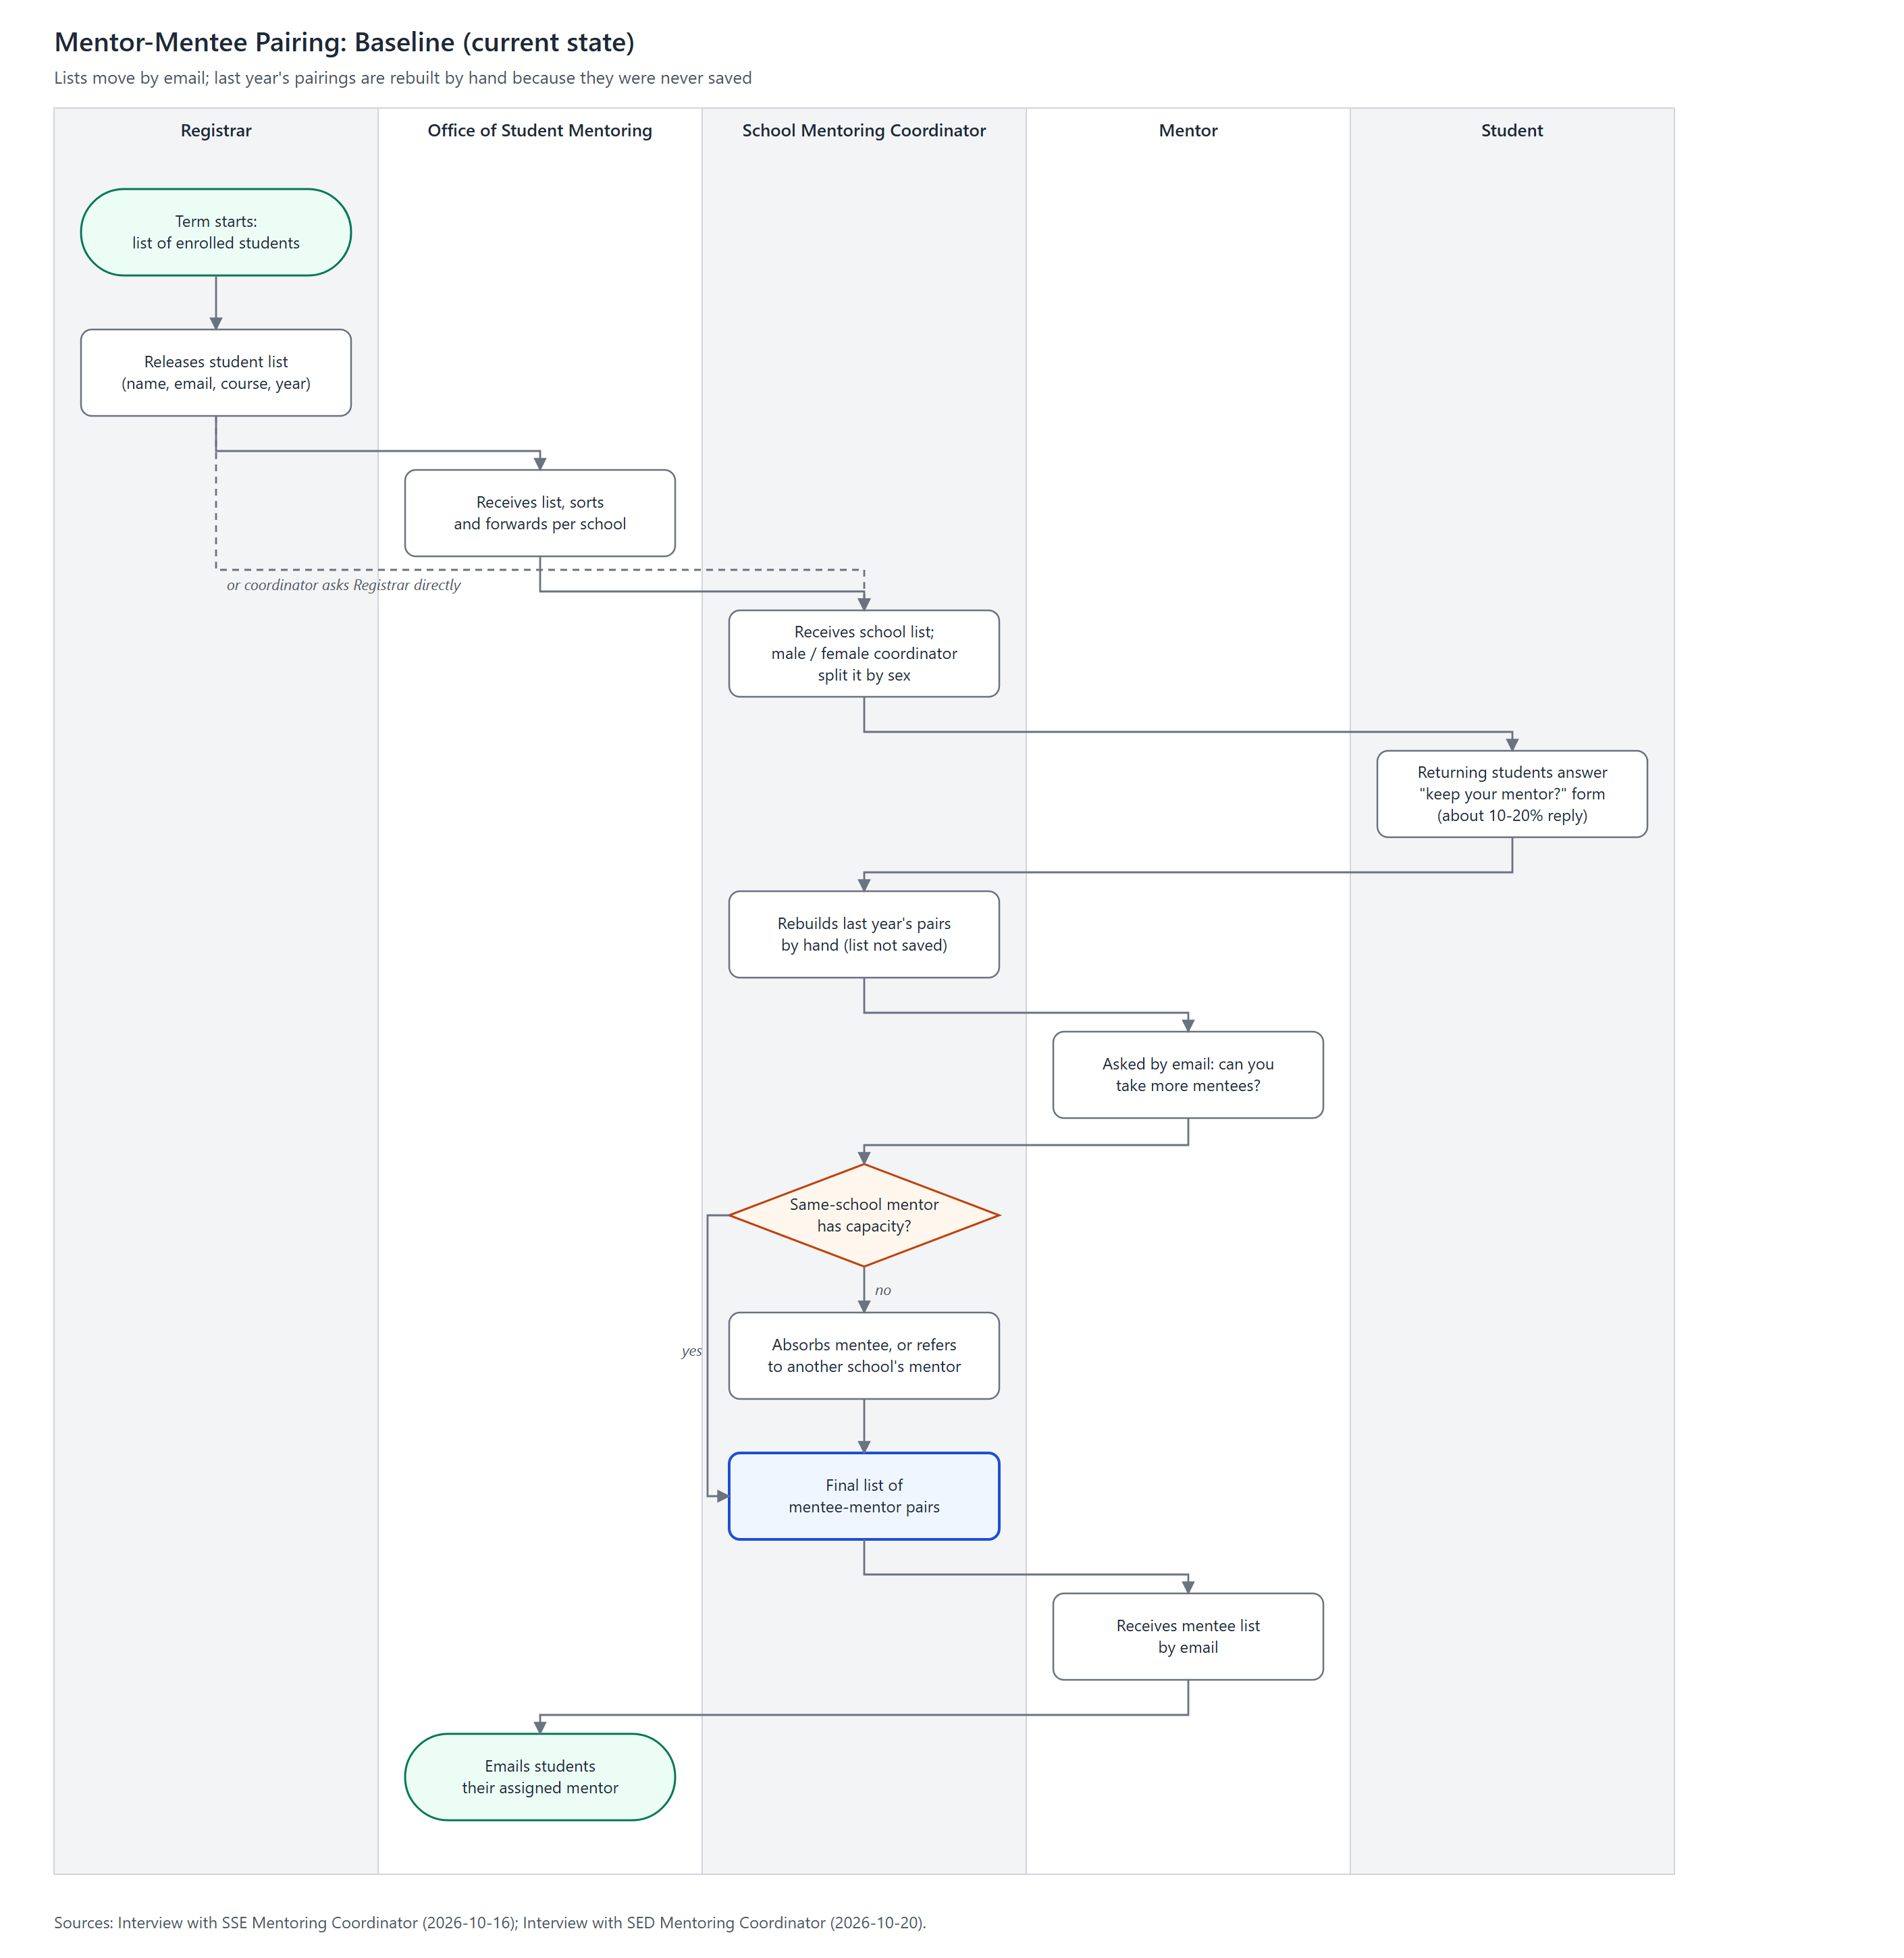
Figure 1. Mentor-Mentee Pairing (Baseline)
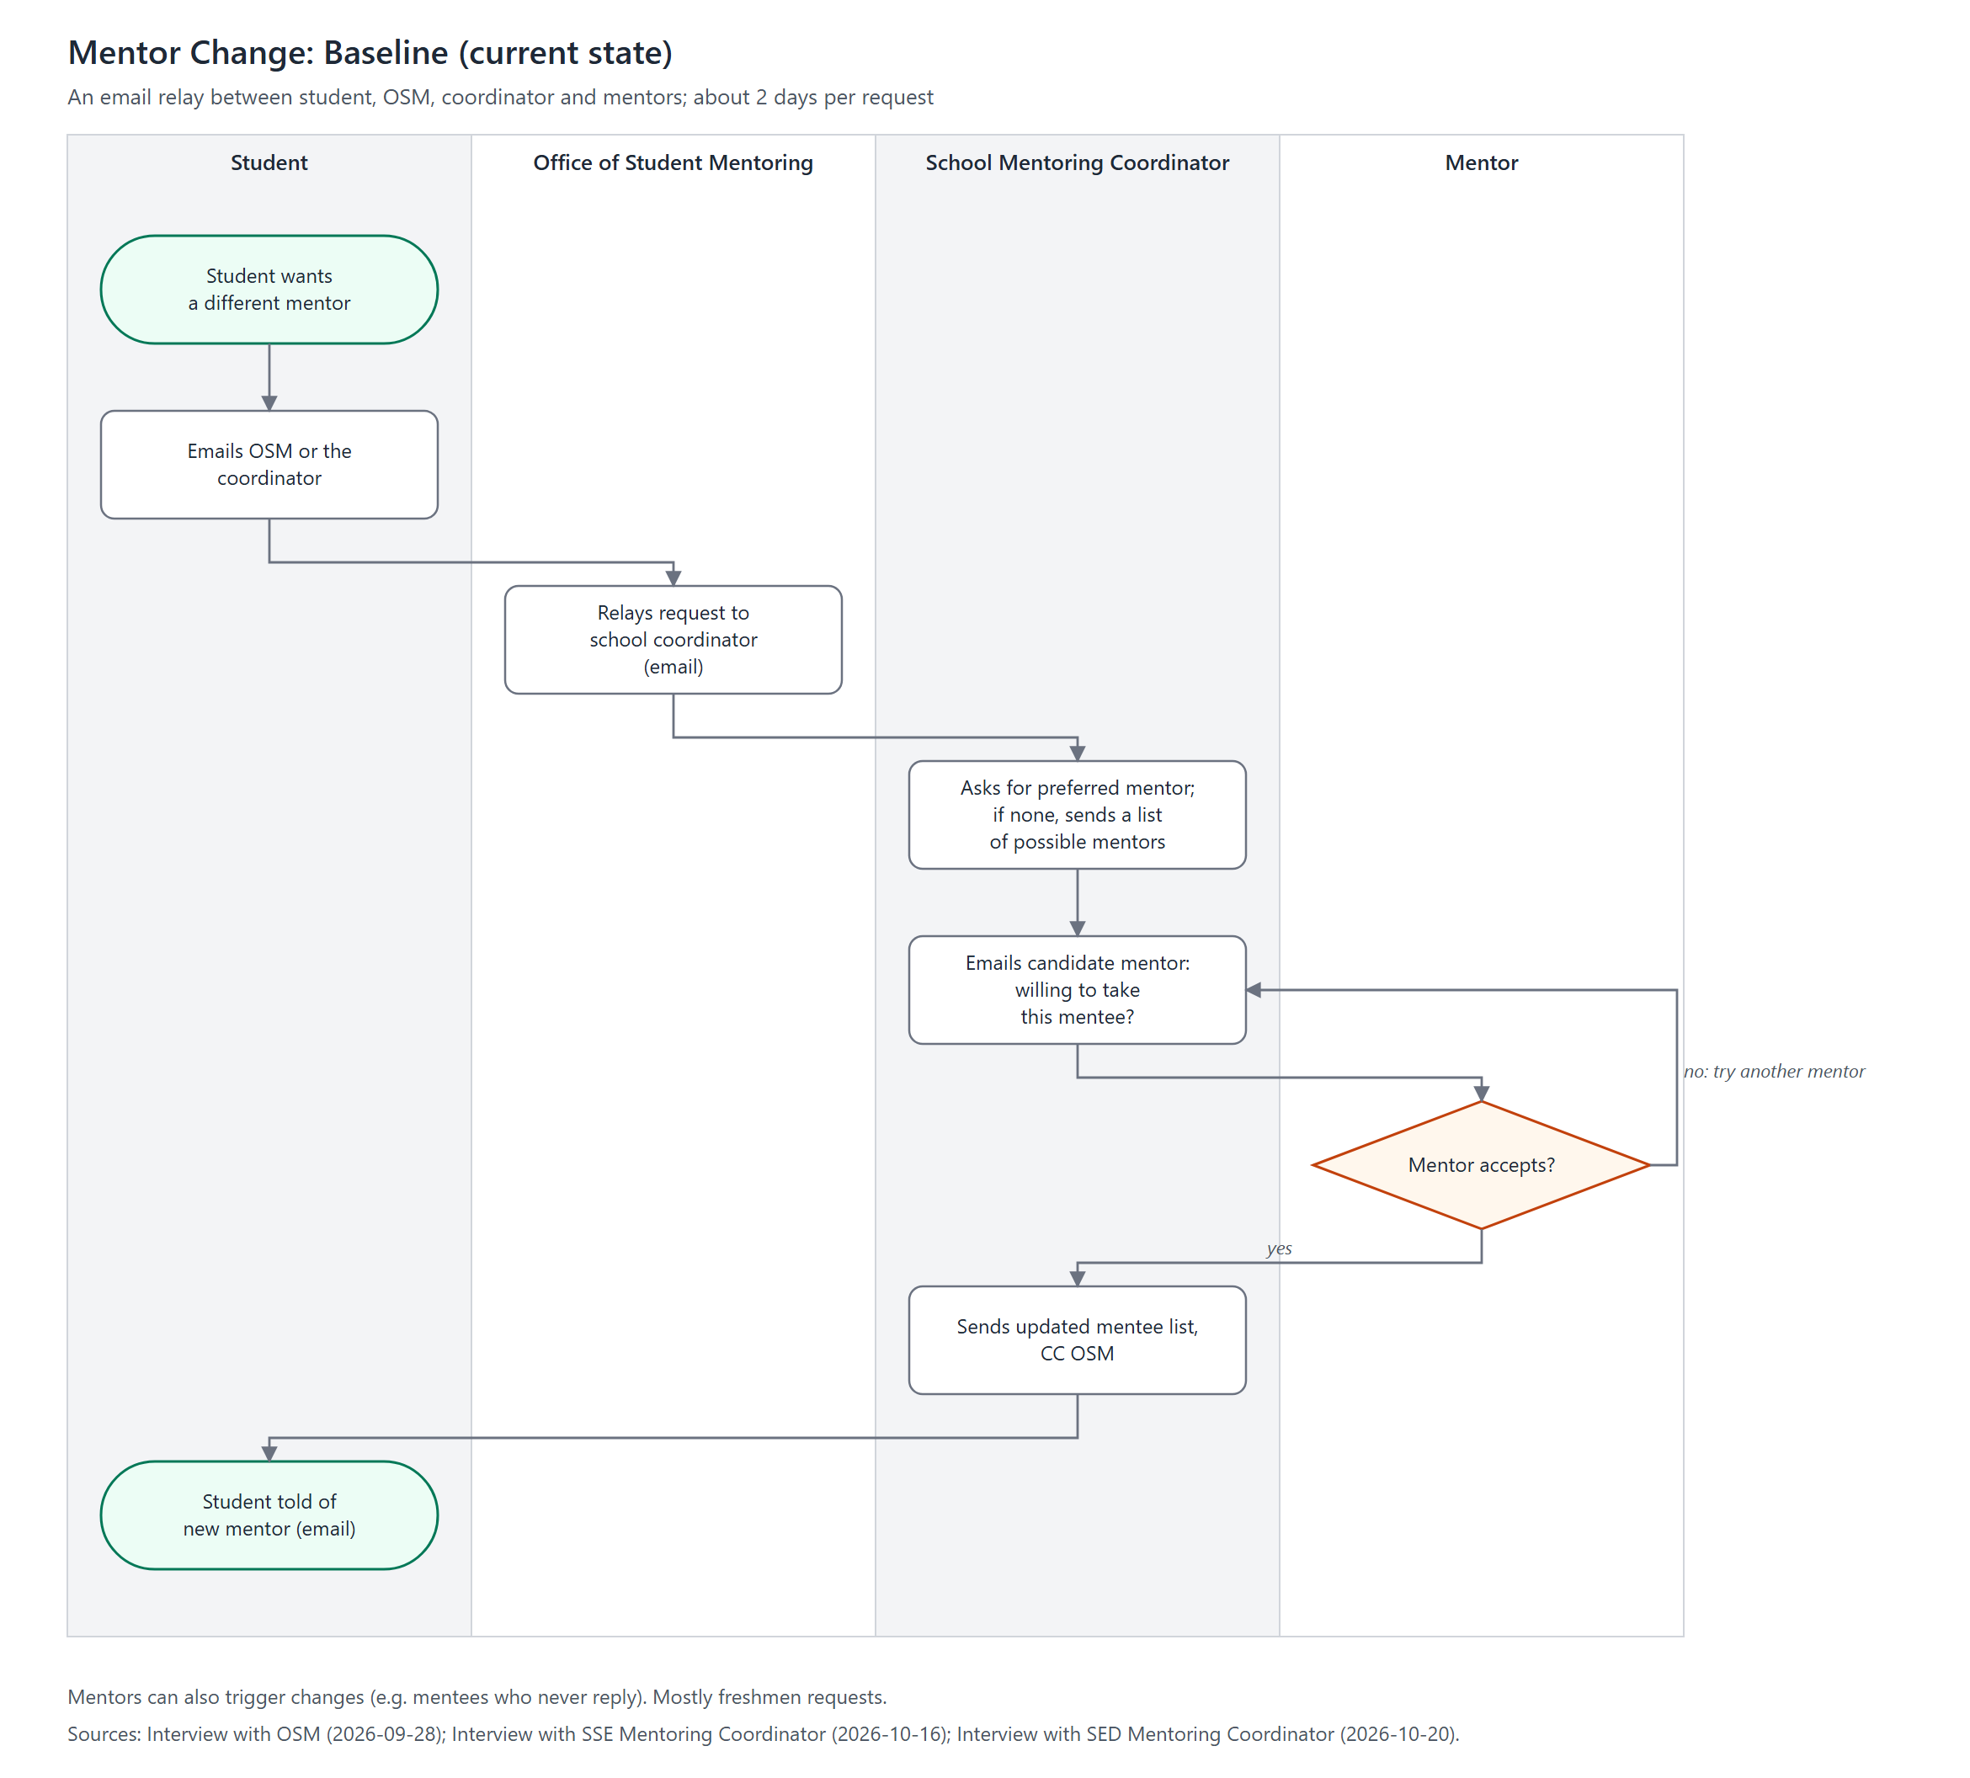
Figure 2. Mentor Change (Baseline)

Architecture Domain
The architecture domain the gap belongs to: Business, Data, Application, or Technology. The Business rows come from the Phase B gap analysis, the Data and Application rows from Phase C, and the Technology rows from Phase D, so the matrix brings all four domains into one view.

Gap
What is missing or must change to move from the Baseline (today) to the Target Architecture. Each gap is stated as the situation today, for example "Pairings are not kept between terms", and traces to a success measure in the Architecture Requirements Specification (SM-01 to SM-08).

Potential Solutions
The candidate roadmap component that would close the gap, using the IDs in Section 2 (BA-01 to BA-08, IS-01 to IS-05, TA-01 to TA-03). These are candidates only; the actual work packages and their sequence are confirmed in Phase E.

Dependencies
What must be in place before the solution can work. A dependency is either another component that must come first (for example, IS-01, the Pairing Register, before IS-03, session logs tied to pairings) or an assumption about a stakeholder that still has to be confirmed (A-02 Registrar, A-03 coordinators, A-04 mentors, A-06 IT Office, in the Architecture Requirements Specification). These dependencies decide the order of the Transition Architectures in Section 3.4.

Transition Architectures
Candidate transitions (to be confirmed in Phase E):
- Transition 1: standardize and centralize the data. Single student-list intake, central pairing register, named data owner, tracked mentor-change requests (BA-01, BA-02, BA-04; IS-01, IS-02, TA-01, TA-02, TA-03).
- Transition 2: one end-to-end workflow. Pairing workflow, capacity, log-to-pairing monitoring and semester reporting in the single platform (BA-03, BA-05, BA-06, BA-07; IS-03, IS-04, IS-05).
- Beyond the target: assisted matching (BA-08), once the register holds enough history.

Implementation Recommendations
Preliminary, to be confirmed in Phase E. Implement in dependency order: WP1 and WP2 (Transition 1), then WP3 and WP4 (Transition 2). The targets below are proposed and still need validation with OSM and the CSA Executive Director.

Criteria Measures of Effectiveness of Projects
Work package | Success measures (ARS) | Target | Checked by
WP1 | SM-02, SM-03, SM-07 | 100% of students paired in the register; previous term's pairings retrievable; one route for the list | OSM data owner, start of each term
WP2 | SM-04, SM-05 | 100% of requests in the queue; settled within 2 working days | OSM, each term
WP3 | SM-02 | All students paired before sessions start | OSM and coordinators, start of each term
WP4 | SM-01, SM-06, SM-08 | 100% of students with three confirmed sessions; 100% of logs matched to a pairing; one report per semester | OSM, reported to the CSA Executive Director

Risks and Issues
ID | Risk | Affects | Mitigation
R-01 | Coordinators keep their own lists and do not use the register (A-03). | WP1, WP3 | Involve coordinators in the design; the register replaces their lists and emails instead of adding work.
R-02 | The Registrar does not agree to one list format, or the freshman list arrives late (A-02, C-04). | WP1 | Agree the format with the Registrar before Transition 1; allow updates for late enrollees.
R-03 | The IT Office lacks capacity to build and maintain the tools (A-06). | All | Stay within Google Workspace (TS1); confirm the support split (TS6) early.
R-04 | Students log sessions late or incorrectly. | WP4 | Mentor confirmation by email link; flag students at least 4 weeks before the semester ends (S4).
R-05 | Personal data is seen by people who should not see it. | WP1, WP4 | Access by role and Data Privacy Act compliance (TS3); the mentor-approval scorecard stays outside the application.
R-06 | External mentors have no UA&P account. | WP2, WP4 | Email-link confirmation without a university account (TS2).

Solution Building Blocks
The application services (S1 to S5) are the architecture building blocks. The candidate solution building blocks below use the university's existing Google Workspace and UA&P accounts (Phases C and D document, Section 4), per TS1. The final products are chosen in Phase E.
Work package | Architecture building block | Candidate solution building block | Standards
WP1 | S1 Pairing Register | Google Sheet in a shared Drive with role-based sharing, loaded by Apps Script from the Registrar's file | TS1, TS3, TS5, TS6
WP2 | S2 Mentor Change Requests | Google Form feeding a tracked request sheet; Apps Script updates the register | TS1, TS2, TS4
WP3 | S1 Pairing Register; S5 Notifications | Google Form for capacity declaration; Gmail notices sent by Apps Script | TS1, TS4
WP4 | S3 Session Logging; S4 Compliance Monitoring and Reporting | Google Form tied to the recorded pairing; email-link confirmation for mentors; Sheets summary and semester report | TS1, TS2, TS3

